**LAB REPORT #11** Name: Owais Rao

**C++ Arrays**  Roll No.:22L-7638

Class: BSEE-1A2

**Introduction:-**

An array is a collection of data elements of same data type. It is described by a single name and each element of an array is referenced by using array name and its subscript number. An array can be initialized along with declaration. For array initialization it is required to place the elements separated by commas enclosed within braces. There are various ways in which we can declare an array. It can be done by specifying its type and size, initializing it or both.

**Objective:-**

* To be able to know how to access values from the arrays.
* To learn how to declare a C++ array.

**Procedure:-**

With the help of lab manual, I was able to write codes for given exercises. They are as follows with their outputs:-

**Exercise 1:-**

#include <iostream>

using namespace std;

void main()

{

int list[10], sum = 0;

cout << endl << "Enter 10 numbers for array: " << endl << endl;

for (int i = 0; i < 10; i++)

{

cin >> list[i];

sum = sum + list[i];

}

cout << endl << endl;

cout << "ARRAY IN INDEX ASCENDING ORDER" << endl << endl;

for (int j = 0; j < 10; j++)

{

cout << list[j] << " ";

}

cout << endl << endl;

cout << "ARRAY IN INDEX DESCENDING ORDER" << endl << endl;

for (int k = 9; k >= 0; k--)

{

cout << list[k] << " ";

}

cout << endl << endl;

cout << " Sum = " << sum << endl;

}

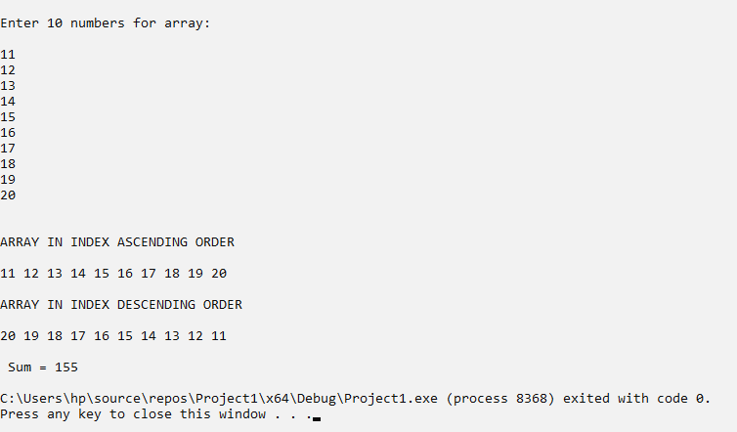

**Exercise 2:-**

#include <iostream>

using namespace std;

int ArrayFunc(int list[10], int size, int keyvalue)

{

int x;

for (int i = 0; i < 10; i++)

{

if (keyvalue == list[i])

{

x = i;

break;

}

else

x = -999;

}

return x;

}

void main()

{

int list[10], keyvalue, size = 10;

cout << endl << "Enter 10 numbers for array: " << endl << endl;

for (int i = 0; i < 10; i++)

{

cin >> list[i];

}

cout << endl << "Enter keyvalue: ";

cin >> keyvalue;

cout << endl << "Index: " << ArrayFunc(list, size, keyvalue) << endl << endl;

for (int j = 0; j < 10; j++)

{

cout << list[j] << " ";

}

cout << endl;

}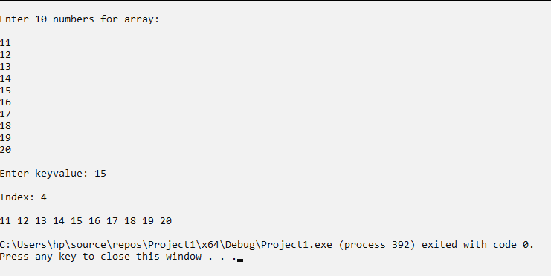

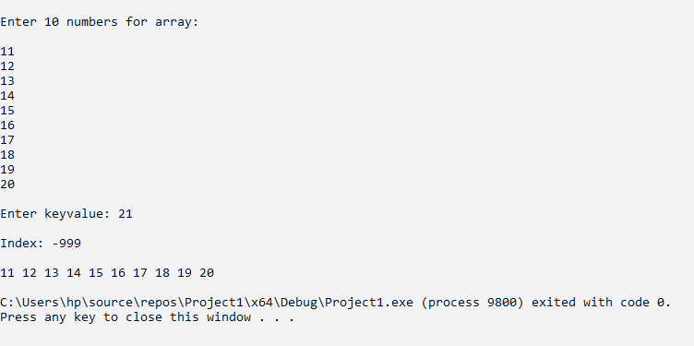

**Exercise 3:-**

#include <iostream>

using namespace std;

void main()

{

double list[5] = { 5.8, 2.6, 9.1, 3.4, 7.0 };

int x = 0;

cout << endl << "\t INPUT" << endl << endl;

for (int i = 0; i < 5; i++)

{

cout << list[i] << " ";

}

cout << endl << endl << "\t OUTPUT";

cout << endl << endl << list[x] << " ";

for (int y = 1; y < 5; y++)

{

list[y] += list[x];

x++;

cout << list[y] << " ";

}

cout << endl;

}

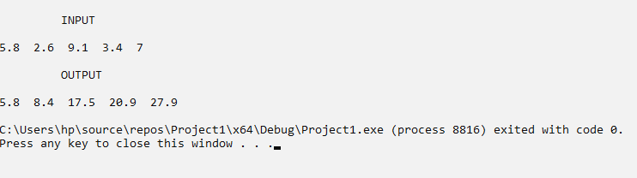

**Issues:-**

No issues were faced.

**Conclusion:-**

* I was able to know how to access values from the arrays.
* I was able to learn how to declare a C++ array.

**Applications:-**

* Arrays are used to store the collection of primitive data types such as int, float, double and char etc of any particular type.
* Arrays are used for code optimization. We can retrieve or sort the data efficiently.
* Arrays are used to implement data structures like a stack, queue, etc.
* Arrays are used for matrices and other mathematical implementations.
* Arrays are used in lookup tables in computers.
* Arrays can be used for CPU scheduling.
* Arrays are used to implement vectors, and lists in C++ STL.
* Data structures like trees also sometimes use the array implementation since arrays are easier to handle than pointers.